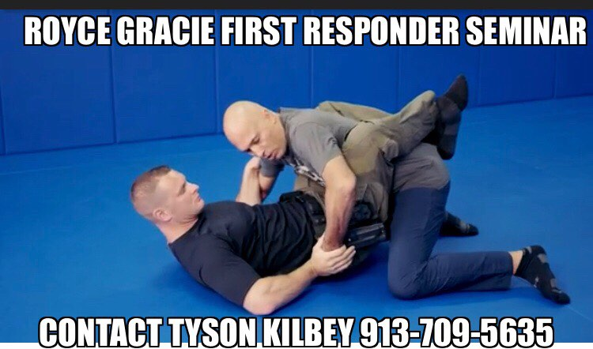

UFC Champion and Legendary Member of the Gracie family is coming to Kansas to do a series of seminars for all levels. On Friday, September 29th , he will be in Lenexa for a special seminar designed specifically for law enforcement. The seminar is two hours in length and there will be value for all experiences levels beginner to advanced!

Date: Friday September 29th, 2023

Time: Seminar 9:00am to 11:00am

Location: 12940 West 87th Street (Next Level Martial Arts Academy)

Contact Name: Tyson Kilbey, 913-709-5635, Tysonkilbey@gmail.com

Cost: $80

Attire: Workout clothes, mat shoes or socks/barefoot

Nearby hotels: Holiday Inn and Suites Overland Park 10920 Nall Ave, Hyatt Place Overland Park 5001 W. 110th

For ANY questions contact Tyson Kilbey at the number or email above.