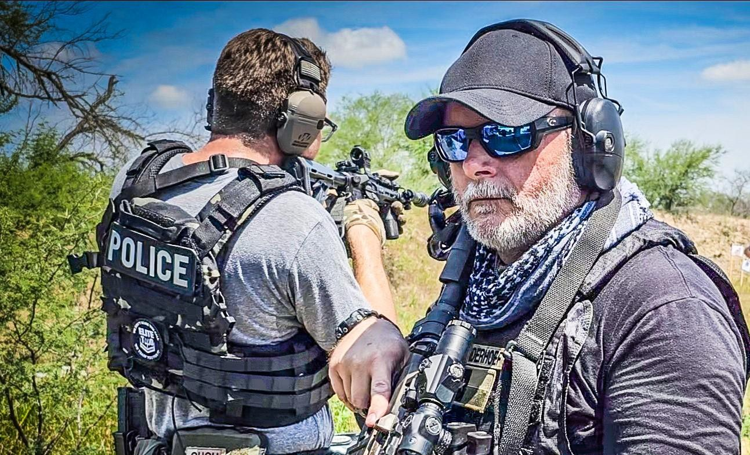

“ACTS OF TERRORISM”

RSVP at [www.elitetwo.com/leo-services](http://www.elitetwo.com/leo-services)

site includes loadout info

20 slots, $375 per Officer

Location:

Mill Creek Rifle Club 7215 Gardner Rd

De Soto, KS 66018

Local POC Johnson County, KS

Sheriff’s Office Deputy Barnett 913-429-4663

[gregory.barnett@jocogov.org](mailto:gregory.barnett@jocogov.org)

For more information email us at

[elitetwojustice@gmail.com](mailto:elitetwojustice@gmail.com)

HOSTED BY JOHNSON COUNTY SHERIFF’S OFFICE

**Instructed by ELITE T.W.O.,**

**R. “Justice” Narvaez Ret. DHS/USCG/DSF**

ELITE T.W.O. (Tactical Weapons & Operations) will be conducting a two-day live fire scenario-based training that will cover Acts of Terrorism, Crisis Mitigation, Active Shooter, Officer Down, Vehicle Ambush & recovery of a VP, Acts of Terrorism, mid-range pistol & AR reactions. This training opportunity is open to all patrolman, SWAT/SRT and Under Cover Officers. Upon completion, each officer will receive a PQS (Personal Qualification Service) letter.

Last day to register is 09MAY2025

ELITE T.W.O. ™

949-351-2715

[www.elitetwo.com](http://www.elitetwo.com/) 29 - 30 May 2025

0730 – 1530 daily

Elite T.W.O.™ is a retired Federal Officer / Career Veteran of DHS/USCG/DSF (Deployable Specialized Forces) an SME Crisis Mitigator and a registered Veteran Onwed business, Government Contractor under General Lic/Liability #NXTKC4VFWT-00-GL.